How to remove acne scars naturally vs dermatologist treatment
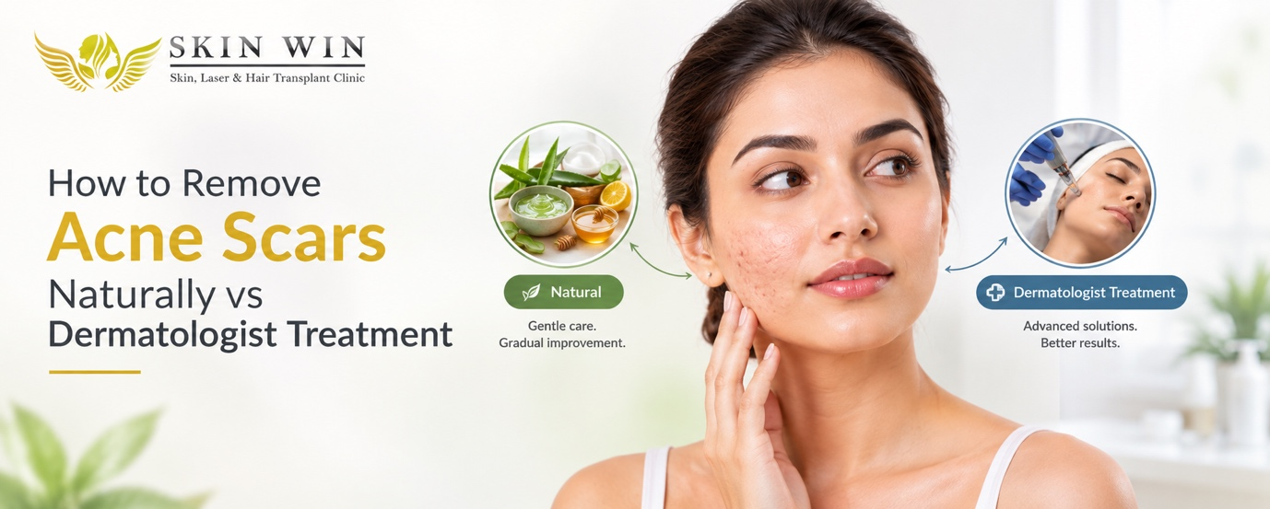

Acne scars can be a lingering reminder of past breakouts. Even after pimples have healed many people are left wondering. If those unsightly pits or dark marks or uneven texture will ever go away. The good news is that improvement is possible and the question most people ask is whether natural home remedies suffice, or if they need to seek professional help from a dermatologist.
Let us explain what acne scars actually are and which natural remedies work best for mild cases. What dermatologists can do for more severe scars and how to decide what's best for your skin. If you are searching for the best dermatologist in Jaipur, a reputable skin clinic in Jaipur, or a dermatologist near me in places like Vaishali Nagar, Kota or Ajmer or Jaipur this information will help you make an informed choice.

What Are Acne Scars?
Acne scars are marks that remain in the skin when inflamed pimples injure deeper layers of the skin. Scar tissue that forms as a result of this damage can take in many forms.
Common types include:
- Atrophic scars: These can be further classiﬁed into ice-pick, boxcar, and rolling scars. Ice-pick scars are narrow, deep marks that resemble an ice pick. Boxcar scars are box-shaped with noticeable edges and rolling scars have a wavy appearance.
- Hypertrophic and keloid scars: Hypertrophic scars are thickened, raised areas, while keloids are similar but tend to be larger and grow beyond the edge of the original wound.
- Post-inflammatory hyperpigmentation (PIH): These are discolored, often dark or brown marks left behind after an inflamed pimple, not actual scars, but frequently mistaken for them.
- Post-inflammatory erythema (PIE): These are pink/red marks also related to inflamed pimples that take longer to fade away.
All these kinds of scars have a different effect, and their importance lies in the fact that most surface-level colored scars like PIE and PIH respond well to time and proper treatment, while deeper textural scars such as atrophic need more specialized attention to be effectively reduced.

How Acne Scars Affect Daily Life
Acne scars can be not only cosmetically but emotionally challenging since they may significantly affect a person’s quality of life. Most of the people feel embarrassed facing others with acne scars, taking photos or even putting on makeup because the flawed skin is not perceived as beautiful. It is better to treat the pimples timely to avoid the formation of scars. Don’t worry! it is necessary to consult a dermatologist about their further keratinization.

Natural Ways to Reduce Acne Scars
Natural methods work best for mild discolouration and very shallow marks. It is rarely erase deep ice-pick or boxcar scars, but they can soften the look of residual pigmentation and support overall skin health. Consistency is important and results take weeks or months, not days.
Here are some commonly used natural approaches:
- Aloe vera
Fresh aloe gel soothes inflammation and supports mild healing. Apply a thin layer of pure gel from the plant or a pure product twice a day. Most of the people notice calmer skin and gradual fading of dark spots with regular use.
- Rosehip seed oil
This oil is rich in vitamins and fatty acids that may help even skin tone. Massage a few drops onto clean skin at night that can improve the appearance of residual marks over time when used consistently.
- Honey
Raw honey has mild antibacterial and moisturising properties. Using it for 15–20 minutes a few times a week may support surface healing and rinse gently afterwards.
- Vitamin C from natural sources or serums
Foods rich in vitamin C support collagen, but topical application works better for skin. A simple vitamin C serum (or diluted lemon juice used carefully and rinsed) can help lighten dark spots. Always follow with sunscreen because vitamin C and citrus that can increase sun sensitivity.
- Tea tree oil (diluted)
A very diluted solution may help keep the skin clear and reduce new breakouts that could lead to more marks. Never apply undiluted tea tree oil—it can irritate.
- Gentle exfoliation with natural acids
Occasional use of diluted apple cider vinegar or yoghurt-based masks provides mild lactic acid action. Overdoing it can worsen irritation, so keep it light and infrequent.
Lifestyle support
Drink enough water, eat a balanced diet with plenty of fruits and vegetables, avoid picking or squeezing pimples and protect skin from the sun every day. Sunscreen with SPF 30 or higher is one of the most important steps because UV exposure darkens existing marks.
These methods are low-cost and accessible. However, scientific evidence for dramatic scar removal with home remedies alone is limited. They mainly help surface pigmentation and mild texture. Deep scars involve loss of collagen deeper in the skin which topical natural products cannot fully rebuild.

Dermatologist Treatments for Acne Scars
When natural methods plateau or scars are deeper, professional treatment becomes more effective. A qualified dermatologist assesses your skin type, scar type, and goals, then creates a personalised plan for you. At a good skin clinic in Jaipur or elsewhere in Rajasthan like SKIN-WIN, treatments are performed with medical-grade equipment under expert supervision.
Common professional options include:
- Chemical peels
Controlled application of acids (glycolic, salicylic, TCA or others) removes damaged outer layers and stimulates new skin. Series of peels can improve colour and mild texture and usually downtime is short.
- Microneedling
Tiny needles create controlled micro-injuries that trigger collagen production. It helps rolling and some boxcar scars. Often combined with PRP (platelet-rich plasma) from your own blood is giving better results. Sessions are spaced a few weeks apart.
- Laser treatments
Fractional lasers (non-ablative or ablative such as CO₂) create precise zones of treatment that remodel scar tissue and boost collagen. Vascular lasers can reduce redness which needs multiple sessions that usually give you progressive improvement with manageable downtime.
- Subcision
A fine needle releases fibrous bands that pull down rolling scars, allowing the skin surface to lift.
- TCA CROSS
High-concentration trichloroacetic acid is carefully applied into ice-pick scars to stimulate collagen from within.
- Fillers
Temporary dermal fillers can plump depressed scars for immediate smoother appearance. Results last months and can be repeated.
Prescription topicals
Stronger retinoids, azelaic acid or other prescription creams speed cell turnover and collagen support better than over-the-counter options.
This kind of treatments are evidence-based and tailored and results vary by individual but most people see meaningful improvement in texture and tone after a planned series of sessions. Generally dermatologist also treats any remaining active acne first so new scars do not form.

Natural Methods vs Dermatologist Treatment: A Clear Comparison

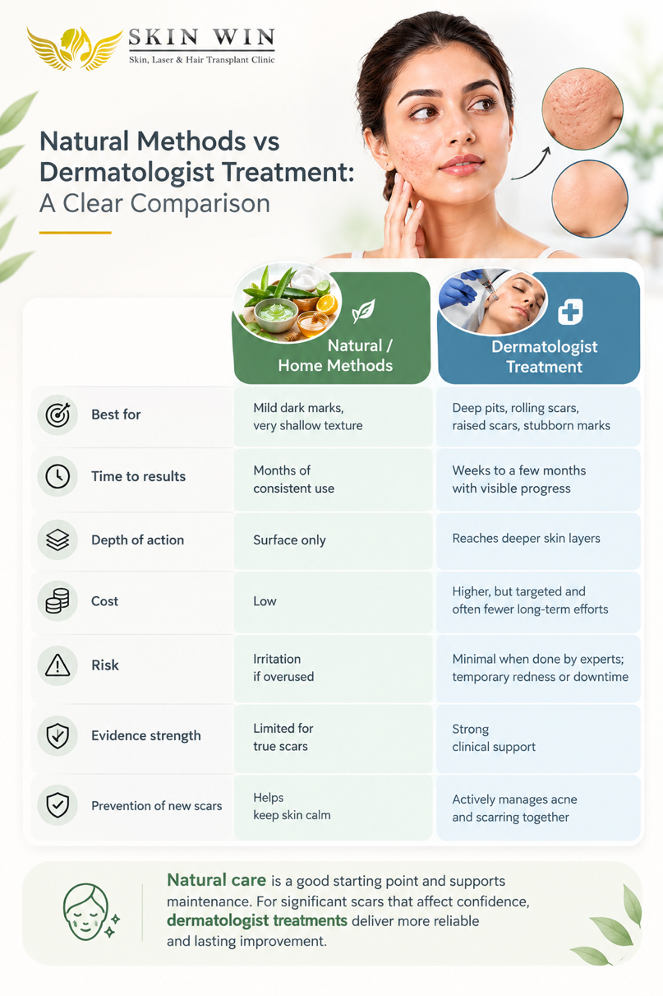

Natural care is a good starting point and supports maintenance. For significant scars that affect confidence, dermatologist treatments deliver more reliable and lasting improvement rather than other options.

When to See a Dermatologist
Consider professional help if:
- Scars are deep, numerous or still changing after several months of home care
- Marks affect your self-esteem or daily life
- You have active acne along with scarring
- Home remedies cause irritation or no improvement
- You want faster, more predictable results
Early consultation prevents scars from becoming more entrenched. If you are looking for a dermatologist in Vaishali Nagar Jaipur, a skin specialist in Kota, the best skin clinic in Ajmer, or simply a dermatologist near me, choose a clinic with experienced doctors, proper diagnostic approach and modern technology.

Why Choose a Trusted Clinic Like SkinWin
Skin-Win clinics across Rajasthan focus on evidence-based skin care. Locations in Jaipur (including Vaishali Nagar and Nirman Nagar areas), Ajmer and Kota make expert care accessible. Skin-Win team have highly qualified dermatologists who assess each case individually. Treatments such as laser scar revision, peels and microneedling are performed with attention to safety and realistic outcomes. At SKIN-WIN, patients receive clear guidance on aftercare and prevention of future breakouts whether you start with gentle natural steps or move to professional options, the goal is healthier, smoother-looking skin and restored confidence.

Practical Tips for Better Results
- Keep active acne under control first—scars form more easily during active breakouts.
- Use broad-spectrum sunscreen daily, even indoors near windows.
- Be patient. Collagen rebuilding takes time.
- Avoid harsh scrubbing or unproven DIY devices that can worsen scarring.
- Follow professional advice on skincare between treatments.

Conclusion
Mild acne marks often respond to consistent natural care and good habits. Deeper scars usually need the precision and strength of dermatologist-led treatments such as lasers, microneedling or peels. The most effective path is often a combination: gentle home support plus professional guidance when needed.
If acne scars are bothering you, do not wait years hoping they will vanish on their own. A consultation with an experienced dermatologist can clarify your options and set a realistic plan. For those in Rajasthan searching for the best dermatologist in Jaipur, a skin clinic in Jaipur, Dermatologist in Vaishali Nagar Jaipur, Skin specialist in Kota, Best skin clinic in Ajmer or a dermatologist near me, SkinWin offers accessible expert care across multiple locations.
Clearer skin is achievable with the right approach. Start with understanding your scar type, try safe natural steps if appropriate, and seek professional help when deeper improvement is needed. Your skin deserves thoughtful care.

Frequently Asked Questions
Can natural remedies completely remove deep acne scars?
No. They may soften mild marks and improve colour, but deep textural scars need professional procedures that stimulate collagen at deeper levels.
How long do dermatologist treatments take to show results?
Many people notice gradual improvement after a few sessions. Full results from collagen remodelling can continue for several months after the treatment course.
Is laser treatment safe for Indian skin tones?
Yes, when performed by experienced dermatologists using appropriate settings and devices suited to different skin types.
Should I treat active acne before scars?
Yes. Controlling breakouts first prevents new scars and allows scar treatments to work better.
Where can I find reliable acne scar treatment in Rajasthan?
Look for established clinics with qualified dermatologists, such as SkinWin locations in Jaipur, Vaishali Nagar, Kota and Ajmer. A proper consultation is the best first step.

Author:
Dr Sonali Gupta, MBBS (Gold Medallist) | MD (Dermatology)
Dr Naina Garg, MBBS, MD (Dermatology)

